DATA SCIENCE
IMPORTANCE
DATA ANALYTICS
IMPORTANCEC
What is exploratory data analysis (EDA)?
Exploratory data analysis (EDA) is used by data scientists to analyze and investigate data sets and summarize their main characteristics, often employing data visualization methods.
EDA helps determine how best to manipulate data sources to get the answers you need, making it easier for data scientists to discover patterns, spot anomalies, test a hypothesis, or check assumptions.
EDA is primarily used to see what data can reveal beyond the formal modeling or hypothesis testing task and provides a provides a better understanding of data set variables and the relationships between them. It can also help determine if the statistical techniques you are considering for data analysis are appropriate. Originally developed by American mathematician John Tukey in the 1970s, EDA techniques continue to be a widely used method in the data discovery process today.

Why is exploratory data analysis important in data science?
The main purpose of EDA is to help look at data before making any assumptions. It can help identify obvious errors, as well as better understand patterns within the data, detect outliers or anomalous events, find interesting relations among the variables.
Data scientists can use exploratory analysis to ensure the results they produce are valid and applicable to any desired business outcomes and goals. EDA also helps stakeholders by confirming they are asking the right questions. EDA can help answer questions about standard deviations, categorical variables, and confidence intervals. Once EDA is complete and insights are drawn, its features can then be used for more sophisticated data analysis or modelling.

Types of exploratory data analysis
There are four primary types of EDA:
- Univariate non-graphical. This is simplest form of data analysis, where the data being analyzed consists of just one variable. Since it’s a single variable, it doesn’t deal with causes or relationships. The main purpose of univariate analysis is to describe the data and find patterns that exist within it.
- Univariate graphical. Non-graphical methods don’t provide a full picture of the data. Graphical methods are therefore required. Common types of univariate graphics include:
  - Stem-and-leaf plots, which show all data values and the shape of the distribution.
  - Histograms, a bar plot in which each bar represents the frequency (count) or proportion (count/total count) of cases for a range of values.
  - Box plots, which graphically depict the five-number summary of minimum, first quartile, median, third quartile, and maximum.
- Multivariate nongraphical: Multivariate data arises from more than one variable. Multivariate non-graphical EDA techniques generally show the relationship between two or more variables of the data through cross-tabulation or statistics.
- Multivariate graphical: Multivariate data uses graphics to display relationships between two or more sets of data. The most used graphic is a grouped bar plot or bar chart with each group representing one level of one of the variables and each bar within a group representing the levels of the other variable.

Exploratory Data Analysis in Python
Exploratory data analysis (EDA) is a critical initial step in the data science workflow. It involves using Python libraries to inspect, summarize, and visualize data to uncover trends, patterns, and relationships. Here’s a breakdown of the key steps in performing EDA with Python:
1. Importing Libraries:
- pandas (pd): For data manipulation and analysis.
- NumPy (np): For numerical computations.
- Matplotlib.pyplot (plt): For basic plotting functionalities.
- Seaborn (sns): A built-on top of Matplotlib, providing high-level visualization.
- Statistics(stats): to understand the central tendency, position measure of dispersion and covariance, correlations, association and causation.
2. Loading the Data:
- Use pd.read_csv() for CSV files, similar functions exist for other data formats (e.g., .xlsx, .json).
3. Initial Inspection:
- Get an overview of the data using df.head(), .tail(), and .info().
- Check data types with df.dtypes.
Data Cleaning:
- Identify and handle missing values using methods like df.isnull().sum().
- Find and address duplicates with df.duplicated().sum().
5. Univariate Analysis:
- Analyze single variables at a time.
- Use descriptive statistics with df.describe() for numerical data.
- Create histograms, box plots, and density plots to visualize distributions.
Bivariate Analysis:
- Explore relationships between two variables.
- Create scatter plots to identify trends and potential correlations.
7. Visualization:
- Effective visualizations are crucial for understanding data.
- Use various plots like bar charts, pie charts, and heatmaps to represent categorical data.

Data Pre-processing
In data-driven processes, we prioritize refining our raw data through the crucial stages of EDA (Exploratory Data Analysis). Both data pre-processing and feature engineering play pivotal roles in this endeavor. EDA involves a comprehensive range of activities, including data integration, analysis, cleaning, transformation, and dimension reduction.
Data pre-processing involves cleaning and preparing raw data to facilitate feature engineering. Meanwhile, feature engineering entails employing various techniques to manipulate the data. This may include adding or removing relevant features, handling missing data, encoding variables, and dealing with categorical variables, among other tasks.

EDA using Pyhton

Data Collection
Data Collection is an essential part of exploratory data analysis. It refers to the process of finding and loading data into our system. Good, reliable data can be found on various public sites or bought from private organizations. Some reliable sites for data collection are Kaggle, GitHub, Machine Learning Repository, et
The data depicted below represents the Used cars that is available on Kaggle. It contains information on the car brand, location, year, kilometers driven, fuel type, transmission, Owner_type, mileage Engine, Power, seats, new price, price.

Step 1: Import Python Libraries
Import all libraries which are required for our analysis, such as Data Loading, Statistical analysis, Visualizations, Data Transformations, Merge and Joins, etc.
import pandas as pd
import numpy as np
import matplotlib.pyplot as plt
import seaborn as sns
#to ignore warnings
import warnings
warnings.filterwarnings('ignore')

Step 2: Reading Dataset
The Pandas library offers a wide range of possibilities for loading data into the pandas DataFrame from files like JSON, .csv, .xlsx, .sql, .pickle, .html, .txt, images etc.
Most of the data are available in a tabular format of CSV files. It is trendy and easy to access. Using the read_csv() function, data can be converted to a pandas DataFrame.
In this article, the data to predict Used car price is being used as an example. In this dataset, we are trying to analyze the used car’s price and how EDA focuses on identifying the factors influencing the car price. We have stored the data in the DataFrame data.
data = pd.read_csv("used_cars.csv")

step 3. Data Cleaning

Data Cleaning refers to the process of removing unwanted variables and values from your dataset and getting rid of any irregularities in it. Such anomalies can disproportionately skew the data and hence adversely affect the results. Some steps that can be done to clean data are:
- Removing missing values, outliers, and unnecessary rows/ columns.
- Re-indexing and reformatting our data.
- Before we make any inferences, we listen to our data by examining all variables in the data.
- The main goal of data understanding is to gain general insights about the data, which covers the number of rows and columns, values in the data, data types, and Missing values in the dataset.
- shape – shape will display the number of observations(rows) and features(columns) in the dataset
There are 7253 observations and 14 variables in our dataset
head() will display the top 5 observations of the dataset

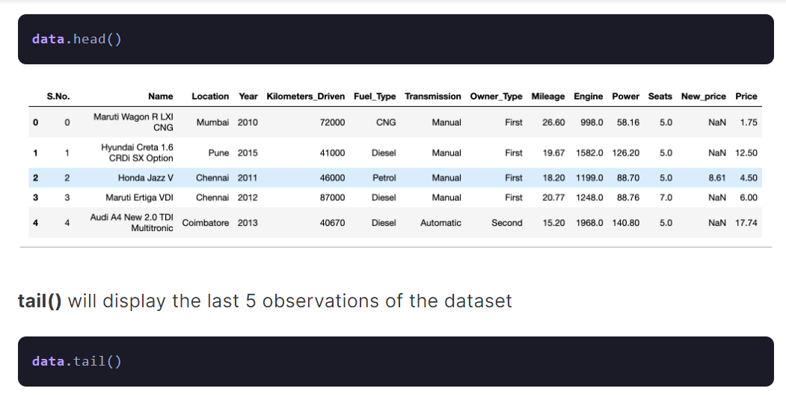
info() helps to understand the data type and information about data, including the number of records in each column, data having null or not null, Data type, the memory usage of the dataset
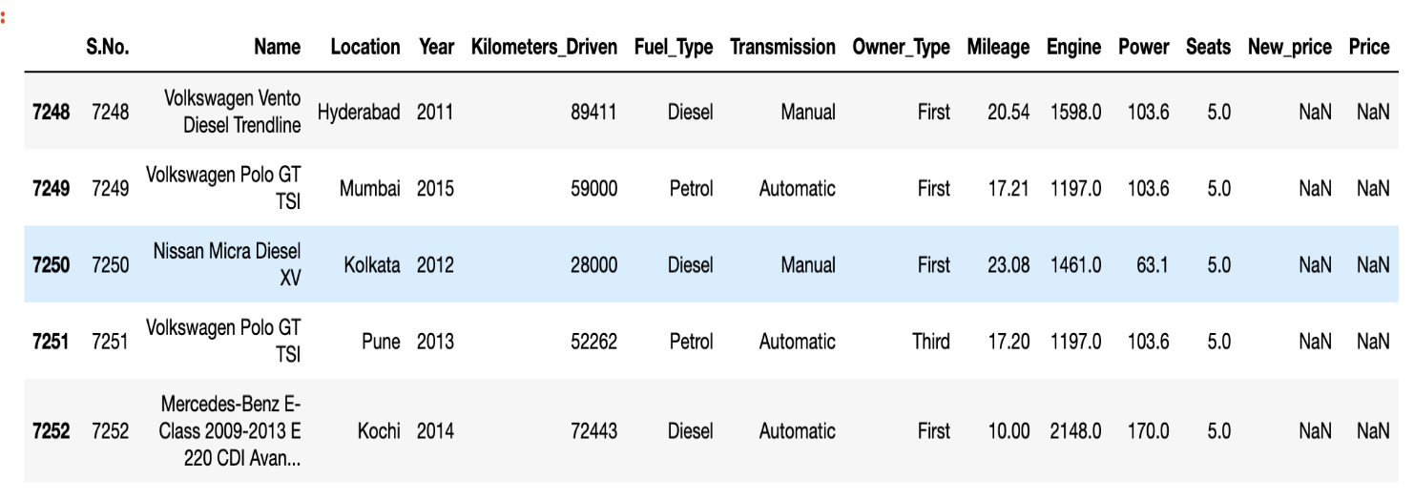
data.info()
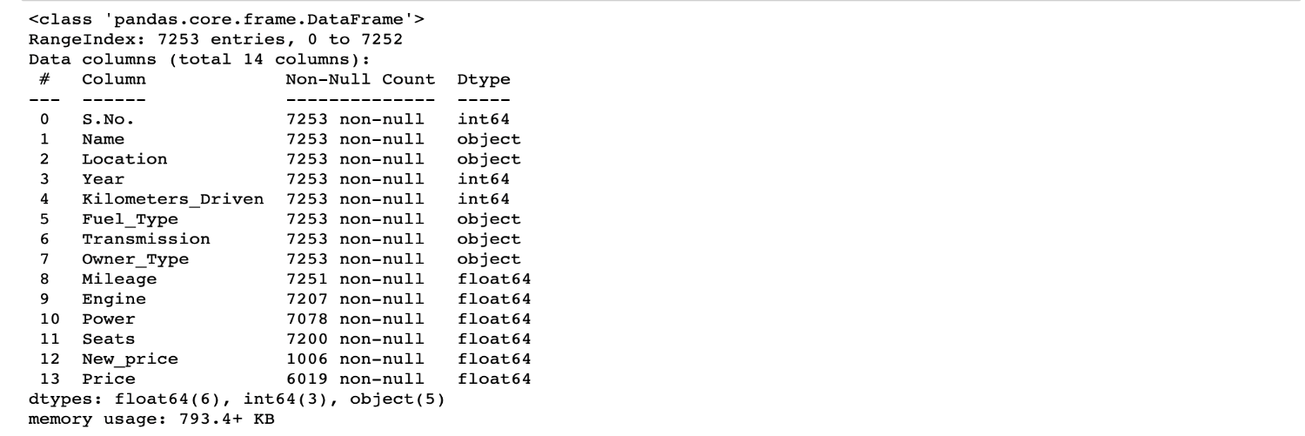

data.info() shows the variables Mileage, Engine, Power, Seats, New_Price, and Price have missing values. Numeric variables like Mileage, Power are of datatype as float64 and int64. Categorical variables like Location, Fuel_Type, Transmission, and Owner Type are of object data type

Missing Values Calculation
isnull() is widely been in all pre-processing steps to identify null values in the data
In our example, data.isnull().sum() is used to get the number of missing records in each column
data.isnull().sum()

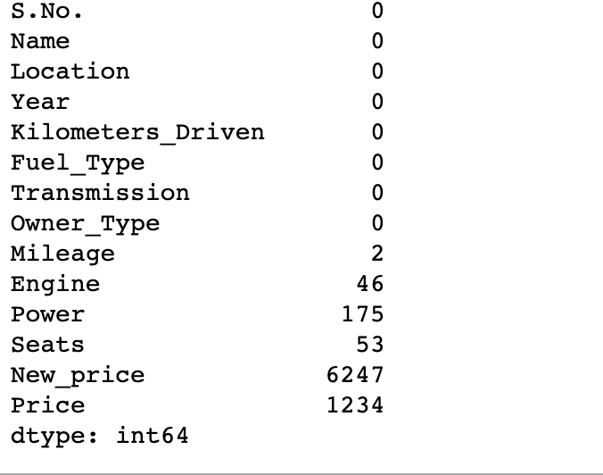

The below code helps to calculate the percentage
(data.isnull().sum()/(len(data)))*100
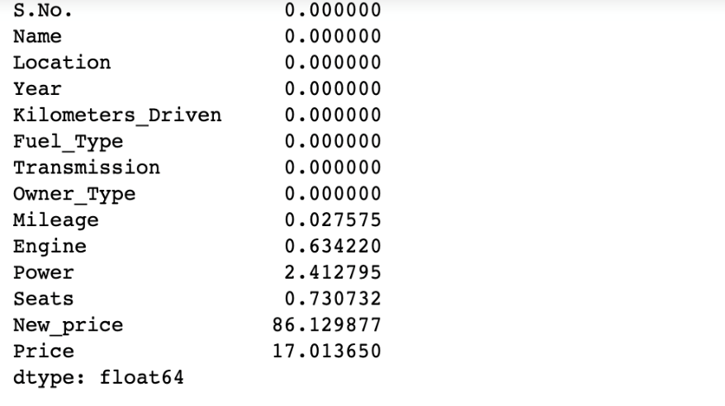
The percentage of missing values for the columns New_Price and Price is ~86% and ~17%, respectively.

idetifying Duplicate values and removing them and
Some columns or variables can be dropped if they do not add value to our analysis. In our dataset, the column S.No have only ID values, assuming they don’t have any predictive power to predict the dependent variable.
# Remove S.No. column from data
data = data.drop(['S.No.'], axis = 1)
data.info()

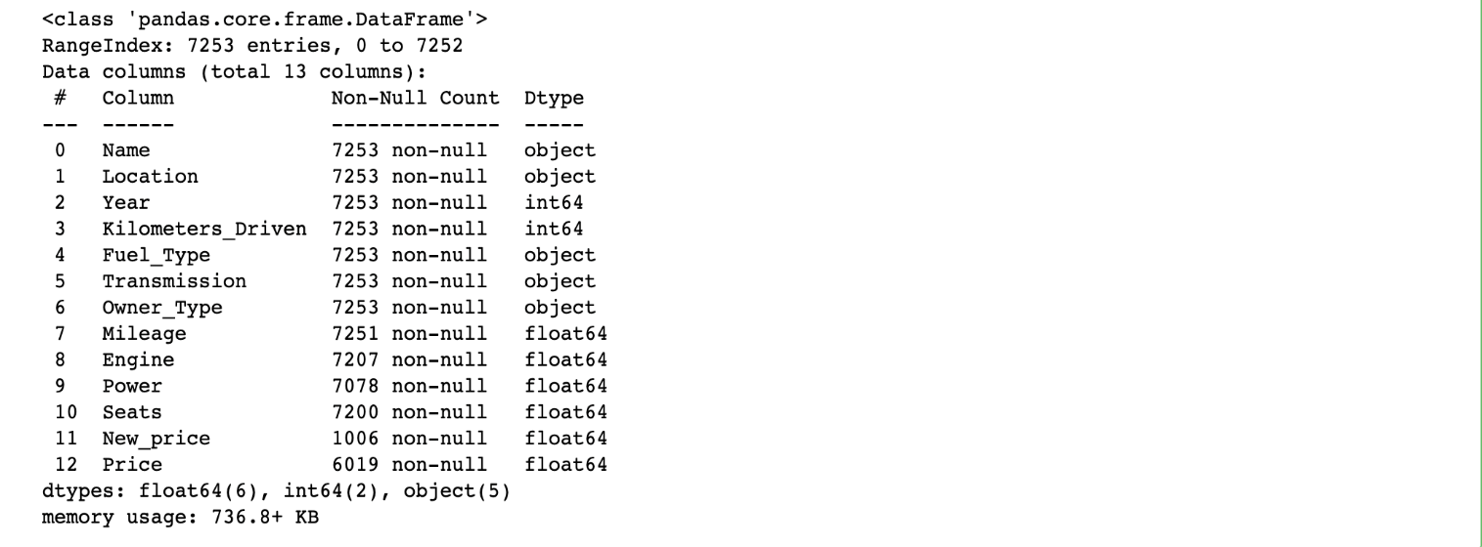ZZZZZZZZZZZZZZZZZZZZZZZZZZZZZZZZZZZZZZZZZZZZZZZZZZZZZZZZZZZZZZZZZZZZAAAAAAAAAAAAAAAAAAAAAAAAAAAAAAAAAAAAAAAAAAAAAAAAAAAAAAAAAAAAAAAAAAAAAAAAAAAAAAAAAAAAAAAAAAAAAAA

Step 4: EDA Exploratory Data Analysis
Exploratory Data Analysis refers to the crucial process of performing initial investigations on data to discover patterns to check assumptions with the help of summary statistics and graphical representations.
- EDA can be leveraged to check for outliers, patterns, and trends in the given data.
- EDA helps to find meaningful patterns in data.
- EDA provides in-depth insights into the data sets to solve our business problems.
- EDA gives a clue to impute missing values in the dataset

Step 5: Statistics Summary
The information gives a quick and simple description of the data.
Can include Count, Mean, Standard Deviation, median, mode, minimum value, maximum value, range, standard deviation, etc.Statistics summary gives a high-level idea to identify whether the data has any outliers, data entry error, distribution of data such as the data is normally distributed or left/right skewed
In python, this can be achieved using describe()describe() function gives all statistics summary of data
describe()– Provide a statistics summary of data belonging to numerical datatype such as int, float
data.describe().T

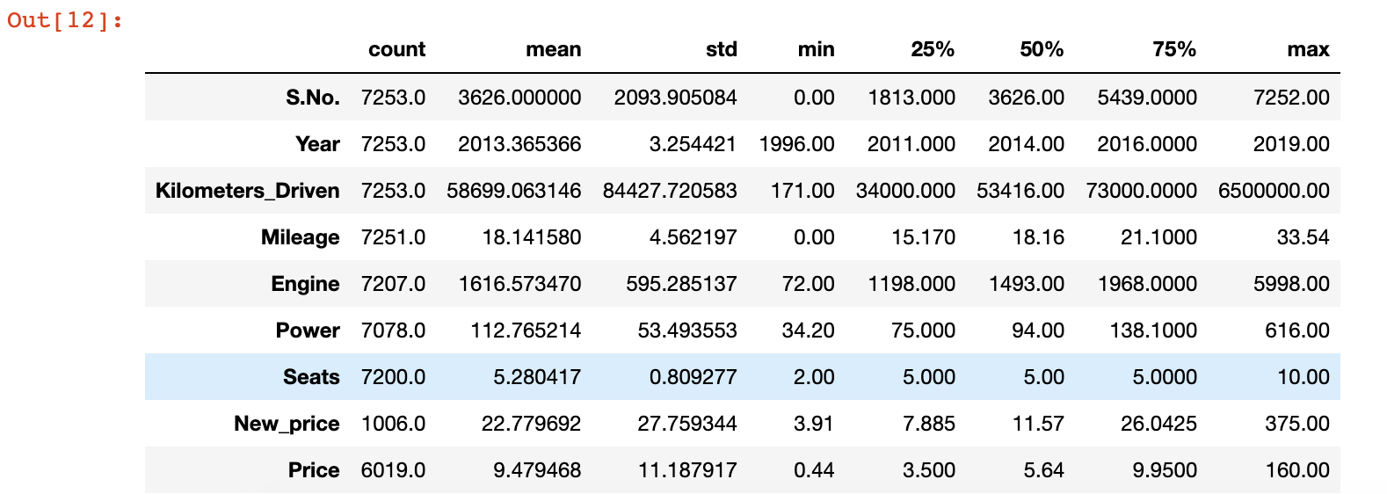

From the statistics summary, we can infer the below findings :
- Years range from 1996- 2019 and has a high in a range which shows used cars contain both latest models and old model cars.
- On average of Kilometers-driven in Used cars are ~58k KM. The range shows a huge difference between min and max as max values show 650000 KM shows the evidence of an outlier. This record can be removed.
- Min value of Mileage shows 0 cars won’t be sold with 0 mileage. This sounds like a data entry issue.
- It looks like Engine and Power have outliers, and the data is right-skewed.
- The average number of seats in a car is 5. car seat is an important feature in price contribution.
- The max price of a used car is 160k which is quite weird, such a high price for used cars. There may be an outlier or data entry issue.
- describe(include=’all’) provides a statistics summary of all data, include object, categories etc
data.describe(include='all').T

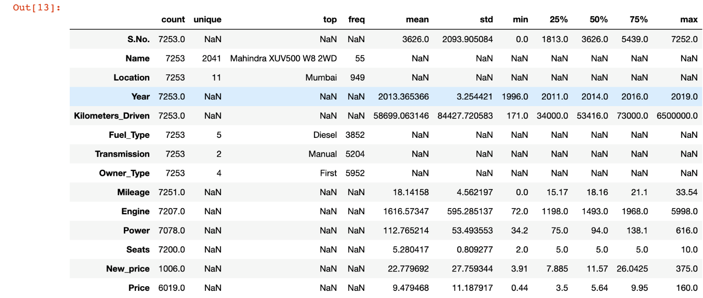

Step 6: EDA Univariate Analysis
Analyzing/visualizing the dataset by taking one variable at a time:
Data visualization is essential; we must decide what charts to plot to better understand the data. In this article, we visualize our data using Matplotlib and Seaborn libraries.
Matplotlib is a Python 2D plotting library used to draw basic charts we use Matplotlib.
Seaborn is also a python library built on top of Matplotlib that uses short lines of code to create and style statistical plots from Pandas and Numpy
Univariate analysis can be done for both Categorical and Numerical variables.
Categorical variables can be visualized using a Count plot, Bar Chart, Pie Plot, etc.
Numerical Variables can be visualized using Histogram, Box Plot, Density Plot, etc.
In our example, we have done a Univariate analysis using Histogram and Box Plot for continuous Variables.
In the below fig, a histogram and box plot is used to show the pattern of the variables, as some variables have skewness and outliers.
for col in num_cols:
print(col)
print('Skew :', round(data[col].skew(), 2))
plt.figure(figsize = (15, 4))
plt.subplot(1, 2, 1)
data[col].hist(grid=False)
plt.ylabel('count')
plt.subplot(1, 2, 2)
sns.boxplot(x=data[col])
plt.show()

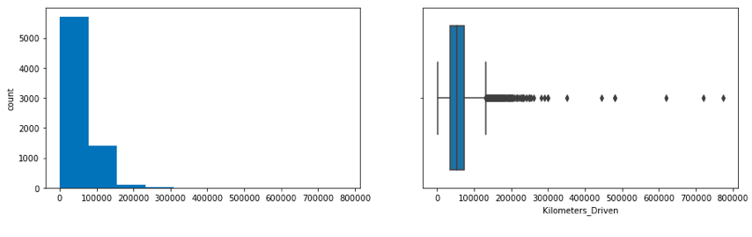

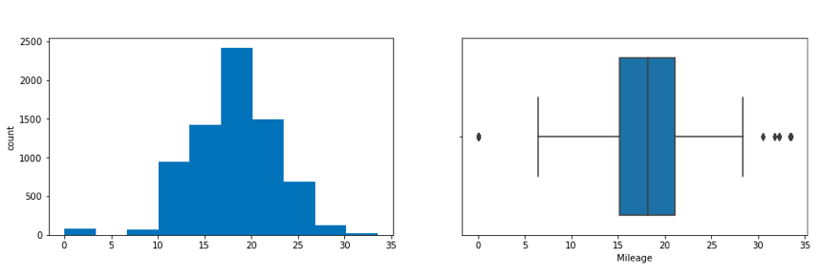

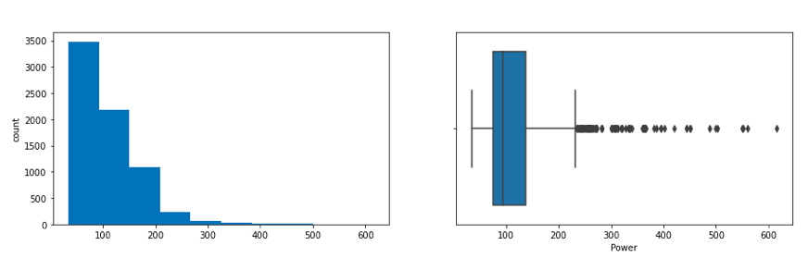

Price and Kilometers Driven are right skewed for this data to be transformed, and all outliers will be handled during imputation
categorical variables are being visualized using a count plot. Categorical variables provide the pattern of factors influencing car price
fig, axes = plt.subplots(3, 2, figsize = (18, 18))
fig.suptitle('Bar plot for all categorical variables in the dataset')
sns.countplot(ax = axes[0, 0], x = 'Fuel_Type', data = data, color = 'blue',
order = data['Fuel_Type'].value_counts().index);
sns.countplot(ax = axes[0, 1], x = 'Transmission', data = data, color = 'blue',
order = data['Transmission'].value_counts().index);
sns.countplot(ax = axes[1, 0], x = 'Owner_Type', data = data, color = 'blue',
order = data['Owner_Type'].value_counts().index);
sns.countplot(ax = axes[1, 1], x = 'Location', data = data, color = 'blue',
order = data['Location'].value_counts().index);
sns.countplot(ax = axes[2, 0], x = 'Brand', data = data, color = 'blue',
order = data['Brand'].head(20).value_counts().index);
sns.countplot(ax = axes[2, 1], x = 'Model', data = data, color = 'blue',
order = data['Model'].head(20).value_counts().index);
axes[1][1].tick_params(labelrotation=45);
axes[2][0].tick_params(labelrotation=90);
axes[2][1].tick_params(labelrotation=90);

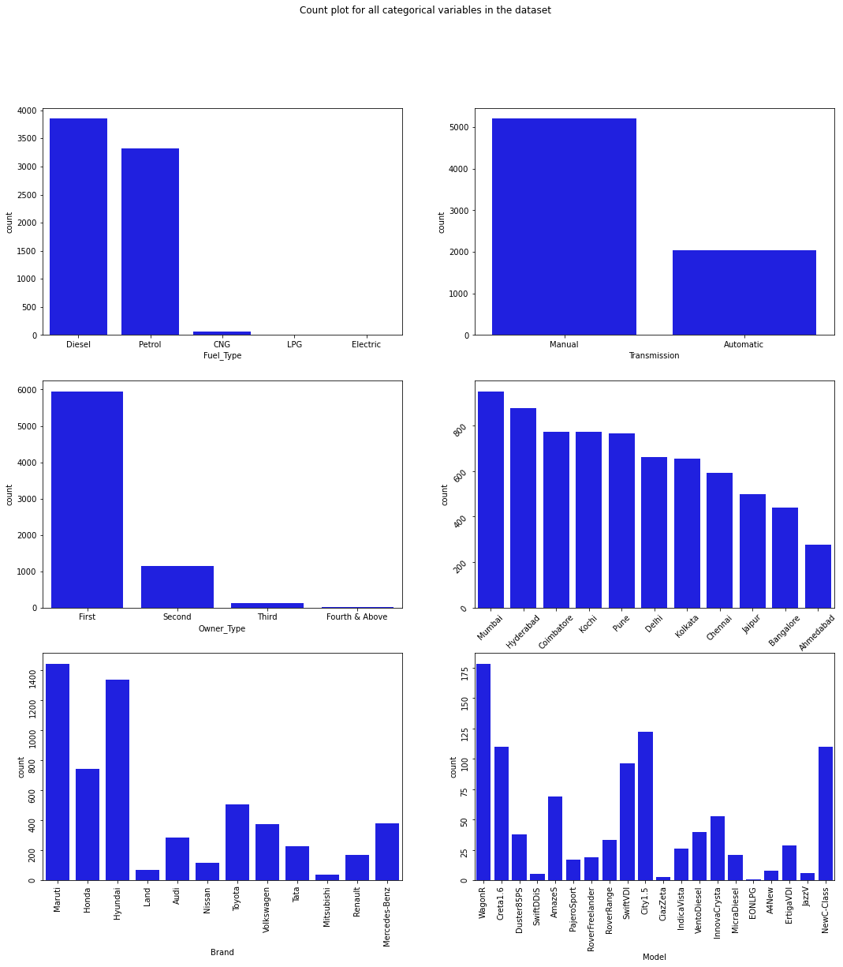

From the count plot, we can have below observations
- Mumbai has the highest number of cars available for purchase, followed by Hyderabad and Coimbatore
- ~53% of cars have fuel type as Diesel this shows diesel cars provide higher performance
- ~72% of cars have manual transmission
- ~82 % of cars are First owned cars. This shows most of the buyers prefer to purchase first-owner cars
- ~20% of cars belong to the brand Maruti followed by 19% of cars belonging to Hyundai
- WagonR ranks first among all models which are available for purchase

Step 8: Data Transformation
Before we proceed to Bi-variate Analysis, Univariate Analysis demonstrated the data pattern as some variables to be transformed.
Price and Kilometer-Driven variables are highly skewed and on a larger scale. Let’s do log transformation.
Log transformation can help in normalization, so this variable can maintain standard scale with other variables:

# Function for log transformation of the column
def log_transform(data,col):
for colname in col:
if (data[colname] == 1.0).all():
data[colname + '_log'] = np.log(data[colname]+1)
else:
data[colname + '_log'] = np.log(data[colname])
data.info()
log_transform(data,['Kilometers_Driven','Price'])
#Log transformation of the feature 'Kilometers_Driven'
sns.distplot(data["Kilometers_Driven_log"], axlabel="Kilometers_Driven_log");

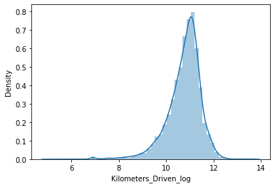
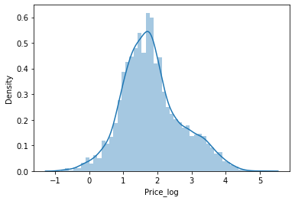

Step 9: EDA Bivariate Analysis
Now, let’s move ahead with bivariate analysis. Bivariate Analysis helps to understand how variables are related to each other and the relationship between dependent and independent variables present in the dataset.
For Numerical variables, Pair plots and Scatter plots are widely been used to do Bivariate Analysis.
A Stacked bar chart can be used for categorical variables if the output variable is a classifier. Bar plots can be used if the output variable is continuous
In our example, a pair plot has been used to show the relationship between two Categorical variables.
plt.figure(figsize=(13,17))
sns.pairplot(data=data.drop(['Kilometers_Driven','Price'],axis=1))
plt.show()
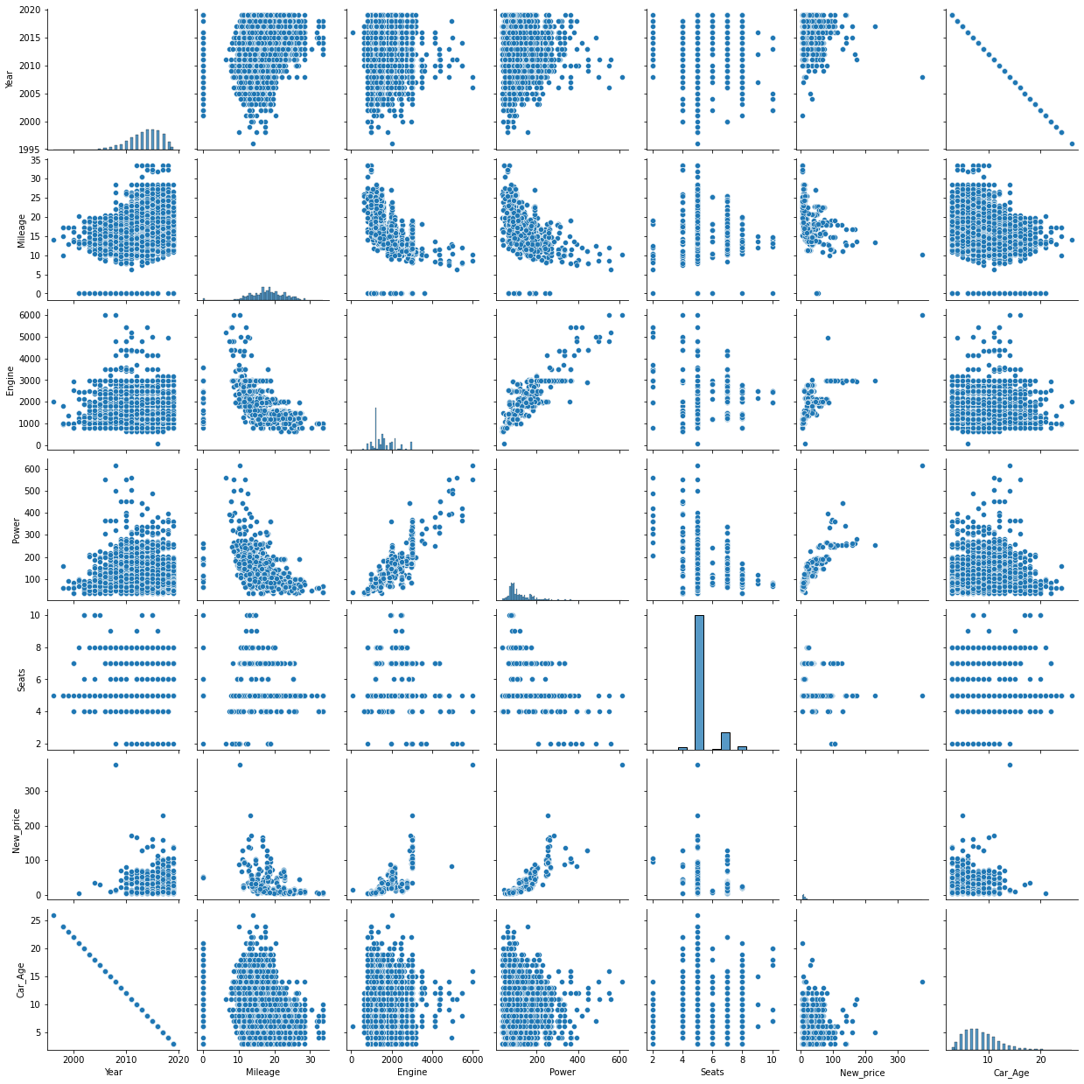

Pair Plot provides below insights:
- The variable Year has a positive correlation with price and mileage
- A year has a Negative correlation with kilometers-Driven
- Mileage is negatively correlated with Power
- As power increases, mileage decreases
- Car with recent make is higher at prices. As the age of the car increases price decreases
- Engine and Power increase, and the price of the car

A bar plot can be used to show the relationship between Categorical variables and continuous variables
fig, axarr = plt.subplots(4, 2, figsize=(12, 18))
data.groupby('Location')['Price_log'].mean().sort_values(ascending=False).plot.bar(ax=axarr[0][0], fontsize=12)
axarr[0][0].set_title("Location Vs Price", fontsize=18)
data.groupby('Transmission')['Price_log'].mean().sort_values(ascending=False).plot.bar(ax=axarr[0][1], fontsize=12)
axarr[0][1].set_title("Transmission Vs Price", fontsize=18)
data.groupby('Fuel_Type')['Price_log'].mean().sort_values(ascending=False).plot.bar(ax=axarr[1][0], fontsize=12)
axarr[1][0].set_title("Fuel_Type Vs Price", fontsize=18)
data.groupby('Owner_Type')['Price_log'].mean().sort_values(ascending=False).plot.bar(ax=axarr[1][1], fontsize=12)
axarr[1][1].set_title("Owner_Type Vs Price", fontsize=18)
data.groupby('Brand')['Price_log'].mean().sort_values(ascending=False).head(10).plot.bar(ax=axarr[2][0], fontsize=12)
axarr[2][0].set_title("Brand Vs Price", fontsize=18)
data.groupby('Model')['Price_log'].mean().sort_values(ascending=False).head(10).plot.bar(ax=axarr[2][1], fontsize=12)
axarr[2][1].set_title("Model Vs Price", fontsize=18)
data.groupby('Seats')['Price_log'].mean().sort_values(ascending=False).plot.bar(ax=axarr[3][0], fontsize=12)
axarr[3][0].set_title("Seats Vs Price", fontsize=18)
data.groupby('Car_Age')['Price_log'].mean().sort_values(ascending=False).plot.bar(ax=axarr[3][1], fontsize=12)
axarr[3][1].set_title("Car_Age Vs Price", fontsize=18)
plt.subplots_adjust(hspace=1.0)
plt.subplots_adjust(wspace=.5)
sns.despine(

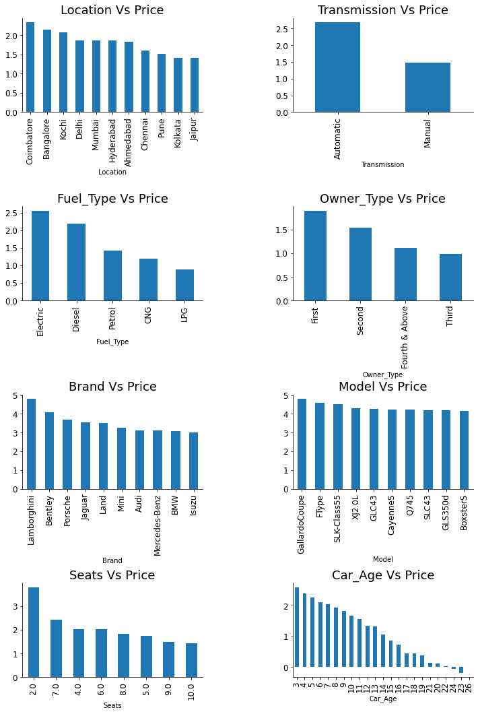

Observations
- The price of cars is high in Coimbatore and less price in Kolkata and Jaipur
- Automatic cars have more price than manual cars.
- Diesel and Electric cars have almost the same price, which is maximum, and LPG cars have the lowest price
- First-owner cars are higher in price, followed by a second
- The third owner’s price is lesser than the Fourth and above
- Lamborghini brand is the highest in price
- Gallardocoupe Model is the highest in price
- 2 Seater has the highest price followed by 7 Seater
- The latest model cars are high in price

Step 10: EDA Multivariate Analysis
As the name suggests, Multivariate analysis looks at more than two variables. Multivariate analysis is one of the most useful methods to determine relationships and analyze patterns for any dataset.
A heat map is widely been used for Multivariate Analysis
Heat Map gives the correlation between the variables, whether it has a positive or negative correlation.
In our example heat map shows the correlation between the variables.

plt.figure(figsize=(12, 7))
sns.heatmap(data.drop(['Kilometers_Driven','Price'],axis=1).corr(), annot = True, vmin = -1, vmax = 1)
plt.show()

From the Heat map, we can infer the following:
- The engine has a strong positive correlation to Power 0.86
- Price has a positive correlation to Engine 0.69 as well Power 0.77
- Mileage has correlated to Engine, Power, and Price negatively
- Price is moderately positive in correlation to year.
- Kilometer driven has a negative correlation to year not much impact on the price
- Car age has a negative correlation with Price
- car Age is positively correlated to Kilometers-Driven as the Age of the car increases; then the kilometer will also increase of car has a negative correlation with Mileage this makes sense

